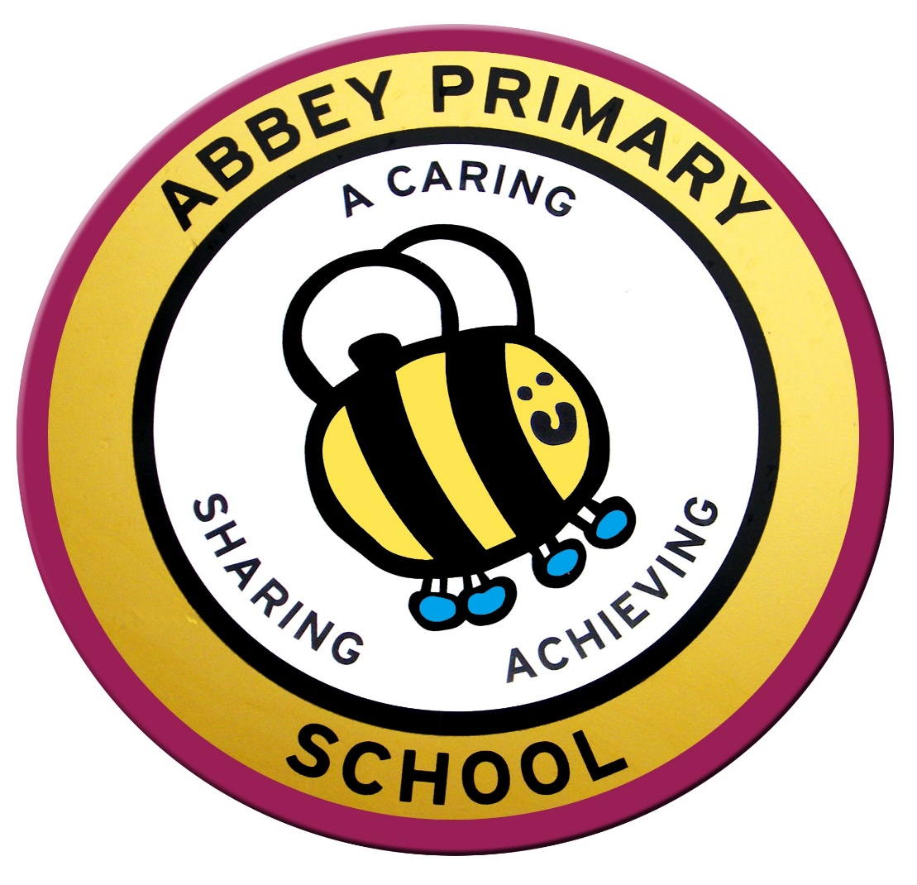

Special Educational Needs Information Report

Reviewed July 2025
Date of next Review July 2026

ABBEY PRIMARY SCHOOL

Special Educational Needs Information Report

September 2024

What kinds of special educational needs does the school make provision for?

Abbey Primary School is a mainstream school, which strives to provide the best learning opportunities for all children. Our school ethos of being a “caring, sharing, achieving school, always giving our best” reflects our inclusive school community. We recognise that all children are individuals who have different learning needs and we work hard to ensure all children are given the right balance of support and challenge.

We constantly strive to update and develop our provision to meet the diverse needs of the children in our care. Our SENCO, supported by the Senior Leadership Team and the SEND Governor, regularly monitors the support and provision for our children who are identified as requiring SEND support to ensure they make progress.

We believe in inclusive practice where barriers to learning are overcome and training, resources and the school environment are focused towards achieving this aim for all our pupils. We have to date provided effective, supportive and creative programmes of learning for children with Autism, Dyslexia, ADHD, visual and hearing impairments, Down’s Syndrome, mild and moderate learning difficulties, speech, language and communication difficulties, and social, emotional and mental health difficulties.

Our SEND Information Report was last reviewed and updated in July 2024.

How does the school know if pupils need extra help and what should I do if I think that my child may have special educational needs?

Our Special Educational Needs Co-ordinator (SENCO) co-ordinates SEND provision, liaising with parents, school staff and specialist advisors from the Local Authority and Health Service. School follows the clear guidelines set out in the SEN Code of Practice 2014, which indicates what are considered Special Educational Needs, and how to recognise children with who may have a possible special educational need.

All teachers are teachers of children with special educational needs and are responsible for identifying pupils with these needs as early as possible.

As a school, we continually monitor and assess the progress of all our children. We track the progress of all children, and where expected progress is not being made, steps and interventions are put in place to support the area of need. When a teacher has a concern about a child’ progress, they follow a graduated response and record their actions on individual education plans and class provision maps.

Prior to children with identified SEND joining our school we will liaise closely with their parents and their previous setting to ensure they receive the appropriate support from the start.

We have an “open door policy” and value our close working partnership with parents/carers. If parents/carers have any concerns about their child’s educational progress or wellbeing, we would urge them to approach their child’s class teacher, the SENCO, or the Head Teacher to make an appointment so that their concerns can be discussed and fully explored. We constantly work with parents to gain a better understanding of their child and involve them in all stages of their child’s education. This includes supporting them in their understanding of the policies and procedures associated with SEND provision and reasonable adjustments in school.

3a. How does the school evaluate the effectiveness of its provision for pupils with special educational needs?

Early identification of SEND helps school ensure that effective provision is put in place and so reduce barriers to learning and enable the child to make the best possible progress.

Our SENCO, supported by the SEND Governor and the Senior Leadership Team, regularly reviews how well SEND support is helping children in our school to make progress. Teachers and teaching assistants are required to produce termly provision maps. These maps identify what exactly is being put into place for vulnerable pupils and allow us to measure the impact of provision. The SENCO also meets regularly with the SEND Governor and presents key information to the governing body on a termly basis.

Through monitoring, observing and assessing a child’s needs, staff work together with the SENCO to put in place appropriate support and provision. The progress of all children is monitored termly and in the Autumn and Spring terms, Parents’ Evenings are held to discuss children’s progress. In the Summer Term, all parents receive an end of year report, detailing progress within all areas of learning and are invited to discuss this with their child’s class teacher. In terms of assessment, if required, a pupil may be assessed using the most appropriate assessment framework; BSquared Connecting Steps, Motional, Autism Education Trust Framework.

Parents/carers of children on the SEND Register with either an EHCP, or who receive support from a range of external agencies, are invited to termly reviews with the SENCO and the child’s class teacher. In some cases these reviews may be more frequent based on the individual needs of the child. Other children on the SEND Register may also be included in the termly review cycle, as appropriate.

3b. How will both the school and I know how my child is doing and how will the school help me to support their learning?

The progress of all children is monitored termly and in both the Autumn and Spring terms Parents’ Evenings are held to discuss the children’s progress. Children who require SEND support and who are being assessed using BSquared Connecting Steps, Motional and/or the Autism Education Trust Framework are set individual targets which are shared and reviewed with parents either bi-annually or, in some instances, termly.

In the Summer term, all parents receive an end of year written report, detailing progress within all areas of learning and are invited to discuss this with their child’s class teacher. In addition, we have an “open door” policy and encourage parents to discuss any concerns they may have as and when they occur, in person with their child’s class teacher who will involve the SENCO or Head Teacher if necessary.

In cases where more frequent regular contact with parents/carers is necessary, this will be arranged based on the individual child’s needs.

If an assessment or referral indicates that a pupil has additional learning needs, the parents/carers and the child (wherever possible) will always be consulted with regards to future provision. Parents are invited to attend meetings with external agencies regarding their child and are kept up to date and consulted on any points of action drawn up in relation to their individual provision.

3c. What is the school’s approach to teaching pupils with special educational needs?

Class based learning is adapted and made accessible for all children in our school. Individual targets are focused on within lessons by the class teacher or a teaching assistant, others may be supported outside of a lesson through a specific intervention programme which will be delivered by either a teacher or a teaching assistant.

3d. How will the curriculum and learning be matched to my child’s needs?

Teachers work hard to ensure work is adapted for children, providing appropriate support and challenge. We aim to deliver a stimulating and exciting curriculum in a multi-sensory way that engages all children and where necessary, children might be supported by a teaching assistant. We also aim to make sure our learning environment meets all of our children’s needs.

3e. How are decisions made about the type and amount of support my child will receive?

Allocation of provision and support is reviewed termly and all decisions made are based on need.

Support offered to each child will reflect targets set and how best they can be achieved. Sometimes this may be through classroom support, small group work or one to one provision. The level of provision will be decided by the class teacher, school SENCO and Headteacher. Information from parents, outside agencies and the pupil themselves will all be taken into account and valued as part of this decision-making process.

3f. How will my child be included in activities outside the classroom, including school trips?

As a school we value highly the benefit of education outside the classroom and believe that all children should have the opportunity to participate in these experiences. Prior to any educational visit, a pre-visit is made by staff and a risk/benefit assessment is carried out, which considers the needs of children with SEND. Where necessary, we meet with parents to discuss any additional support that may be required. We also aim to ensure all children have the chance to be part of lunchtime or after school clubs. We endeavour to ensure that reasonable adjustments are made to enable all children to be able to benefit from the full range of trips and extra-curricular activities available. Our after school clubs are mostly run by teachers from our school and any outside providers are supported by a teacher from our school.

3g. What support will there be for my child’s overall well-being?

The social and emotional wellbeing of our pupils is a priority and we work hard to maintain a strong community ethos. Our PSHE and RSHE framework has been developed to provide the opportunity for children to discuss issues such as positive relationships, keeping healthy, self-esteem and teamwork within the curriculum. Our school values form an integral part of all pupils’ learning and each value has a termly focus that enables all children to develop their understanding of social and emotional wellbeing. Weekly phase assemblies focus on particular aspects of a term’s value and class assemblies provide further opportunity for children to develop their understanding through focused discussion. Some children receive bespoke 1:1 ‘Values’ lessons to enable them to develop their understanding in smaller steps. Additionally, where necessary, specific plans are put in place to support a child’s wellbeing and in these instances parents are consulted. This may involve one to one intervention work, small group intervention work or referral to an outside agency for more specialised support.

4. Who is the school’s special educational needs co-ordinator (SENCO) and what are their contact details?

The SENCO at our school, Mrs Elaine Lovatt, can be contacted through the school office on 01623 481117 and an appointment will be arranged.

5a.What training have staff supporting special educational needs had and what is planned?

We aim to keep all school staff up to date with relevant training and developments in teaching practice in relation to the needs of pupils with SEND.
In the past academic year2025-2026, staff training has comprised of:
- SSS Safeguarding and Child Protection training for all staff
- Prevent Duty Refresher training
- Working Together to Safeguard Children training for SENCO, Foundation Stage Lead, Breakfast/After School Manager and Family Support Worker
- Physical Disability Specialist Service – Handling Children and Young People with a Physical Disability (refresher training) for two Teaching Assistants
- Nottinghamshire NHS Speech and Language Network and training attended by our Language Lead TA
- Coping with Risk Behaviours (Nottinghamshire County Council) training for some Teaching Assistants
- ELSA Supervision Support for two qualified TAs
- St John’s Ambulance Paediatric First Aid – TA training
- Sherwood Area Partnership Forest Learning Network – TA working group
- Handling Children and Young People with a Physical Disability
- Fire Safety Awareness
- Making Sense of Autism
- Zones of Regulation whole school staff training
- Whole school training developing awareness of school’s approach to supporting pupils with SEND
- Early Career Teacher (ECT) induction
The SENCO attends relevant SEND courses, Family SEND meetings and facilitates/signposts relevant SEND focused external training opportunities for all staff. The SENCO also attended three Samworth family Springboard meetings throughout the year and the AFN moderation day.

We recognise the need to train all our staff on SEND issues. The SENCO, with the Senior Leadership team, ensures that training opportunities are matched to school improvement priorities and those identified through the use of provision management.
5b. What specialist services and expertise are available at or accessed by our school?
We have links with a wide range of outside agencies who offer specific guidance and support to our school and families. These include:

- Educational Psychologist
- Therapists including those for Speech and Language, Occupational and Physiotherapy and the Physical Disabilities Service
- Local Authority Advisors including those for Early Years, Cognition and Learning, Communication and Interaction, Hearing Impairment, Visual Impairment and Personal, Social, Emotional Development team.
- Health Services including the Healthy Families Team, Small Steps Service, Early Help Unit, the Primary Mental Health Team (PMHT) and Child and Adolescent Mental Health Service (CAMHS)
- Children’s Social Care
- SAP (Sherwood Area Partnership)
- CASY Counselling
- Nottinghamshire County Council Kinship Support Services
- Outreach services including voluntary organisations

We seek support from outside agencies for staff and families whenever it is needed. The SENCO oversees provision within our school. Staff training is ongoing to ensure the school is kept up to date with any changes and priorities. The training needs within our school reflect the needs of the staff and children we work with. Our SENCO meets regularly with SENCOs from other local schools in meetings chaired by an Educational Psychologist and SFSS link. These are called Springboard Meetings.

6. How will equipment and facilities to support pupils with special educational needs be secured? How accessible is the school setting?
Our school building is fully wheelchair accessible with lift access to the first floor. Evac Mats are available for emergency evacuation from the first floor and identified members of staff have been trained in their use. We have 3 disabled toilets and a fully accessible hygiene room with shower bed and hoist. The school also has a fully equipped sensory room. There are 2 designated disabled bays in the school car park nearest to the entrance.
Any additional equipment will be sourced through the support services following protocol. If the equipment cannot be accessed through these services this will be discussed with parents/carers and decisions made together on how to access necessary equipment.
7. What are the arrangements for consulting parents of pupils with special educational needs? How will I be involved in the education of my child?
We have an “open door policy” and encourage parents to discuss any concerns they have as when they occur with their child’s key worker or class teacher. Parents can also make an appointment to see the SENCO or Head Teacher if necessary.
Parents Evenings’ are held termly to discuss the children’s progress. Children with SEND are assessed using BSquared Connecting Steps, Motional and the Autism Education Trust Framework (dependent upon need), and any targets identified are shared and reviewed with parents. In the Summer term, all parents receive an end of year written report, detailing progress within all areas of learning and are invited to discuss this with their child’s class teacher.

Parents are kept up to date with their child’s progress through termly parents’ evenings, SEND review meetings and reports at the end of the school year. Occasionally it may be necessary to arrange additional meetings based on individual need.

Parents also have the opportunity to express their views through the annual parent questionnaire.

8. What are the arrangements for consulting young people with SEND and involving them in their education?
We endeavour to involve children in the setting and reviewing of their targets. Our SENCO and SEND Governor undertake pupil interviews in the Autumn and Summer terms with the pupils with SEND to ascertain their views on school life and the support they are receiving. We actively encourage all children to participate fully in all aspects of school life.

9. What do I do if I have a concern or complaint about the SEND provision made by the school?

If parents are unsure about any of the support or provision being made for their child, they should not hesitate to contact the school office to make an appointment with their child’s class teacher, our SENCO or Head Teacher. If parents feel their concern is not resolved through this process, they should refer to our Complaints Procedure which can be found on our school website.

10. How does the governing body involve other organisations and services in meeting the needs of pupils with special educational needs and supporting the families of such pupils?
The governing body delegates the day-to-day organisation and liaison to the SENCO who works in conjunction with the Headteacher, and reports back to the full governing body on a termly basis. The SEND Governor visits school regularly to support and challenge the SENCO regarding provision and progress of SEND pupils and to ensure that statutory obligations are being met.

11. How does the school seek to signpost organisations, services etc who can provide additional support to parents/carers and young people?

The school will signpost parents to use the Local Offer website or to specific support groups as appropriate.

12i. How will the school prepare and support children who join the school?

We encourage visits to our school before applying. Careful planning is made for all children but for children with an identified SEND, an additional transition plan may be put in place. This will generally include early discussions with the school/setting they are coming from and any external agencies that are providing existing support. Parents are involved in transition discussions so that the needs of the child and any particular concerns are shared.

12ii. Transfer between phases of education

The transfer to a new school can be an anxious time for both child and parent and we encourage visits to our school before applying. Careful planning is made for all children but for children with an identified SEND, an additional transition plan may be put in place. This will generally include early discussions with the school they are coming from or going to and any external agencies that are providing existing support. Parents are involved in transition discussions so that the needs of the child and any particular concerns are shared. Staff at the new school then meet with the child and specific visits are often planned, allowing the child to familiarise themselves with the learning environment and the staff who will be working with them.

12iii. Prepare for adulthood and independent living

Appropriate independence and life skills will be taught during the child’s school journey. Our updated PHSE and RSE curriculums aim to teach and prepare children for their next phase of education.

13. Where can I access further information?

Parents can also gain support and advice from ‘Ask Us Nottinghamshire’ www.nottshelpyourself.org.uk and the Local Authority Local Offer (www.nottinghamsire.sendlocaloffer.org.uk/)

Report written by the SENCO and approved by the Headteacher and Governing Body

